***PAAREES PERFUMES***

***Christian Diors***

***FOR WOMEN***

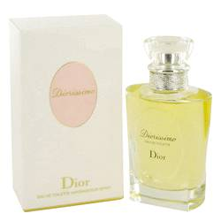

# *Dolce Vita*

***Description:***

Dolce Vita by Christian Dior Perfume. Live life to the fullest with a feminine scent that celebrates "la dolce vita," the sweet life. Launched by venerable designer Christian Dior in 1994, Dolce Vita for women captures a sense of vitality and an aura of romance. It combines intoxicating floral elements of magnolia, lily and rose with delicious fruity notes of apricot and peach. Wear this beguiling Christian Dior fragrance creation every day to reflect your unique character, to inspire interest and to ignite passion.